PSA Oxygen Generator Specification (Vehicle-Mounted Type, 12V, 3LPM Capability)

Product Overview
The DC 12V Vehicle-Mounted PSA Oxygen Generator is a compact and high-efficiency solution designed for mobile applications, including fish transport vehicles, emergency response units, and other on-the-go oxygen supply systems.
This generator delivers 3 LPM of oxygen at 90% purity with an outlet pressure of 1 bar, supplied by a compressor input pressure of less than2 bar. Powered by DC 12V, it ensures reliable and continuous oxygen generation wherever mobility is required.
A key design feature is the separation of the compressor unit and the PSA adsorption bed into distinct modules. This modular configuration:
- Optimizes space utilization within vehicles
- Facilitates easier installation and maintenance
- Enhances airflow and operational efficiency
Using advanced Pressure Swing Adsorption (PSA) technology, nitrogen is selectively adsorbed from compressed air, producing high-purity oxygen consistently. The low-pressure operation ensures safe and reliable performance for mobile applications.
Key Features & Benefits:
- Stable oxygen flow at 3 LPM with 90% ±3% purity
- Modular design separating compressor and PSA bed for optimized space and accessibility
- Low outlet pressure minimizes system stress and enhances safety
- Compact, lightweight, and ideal for vehicle integration

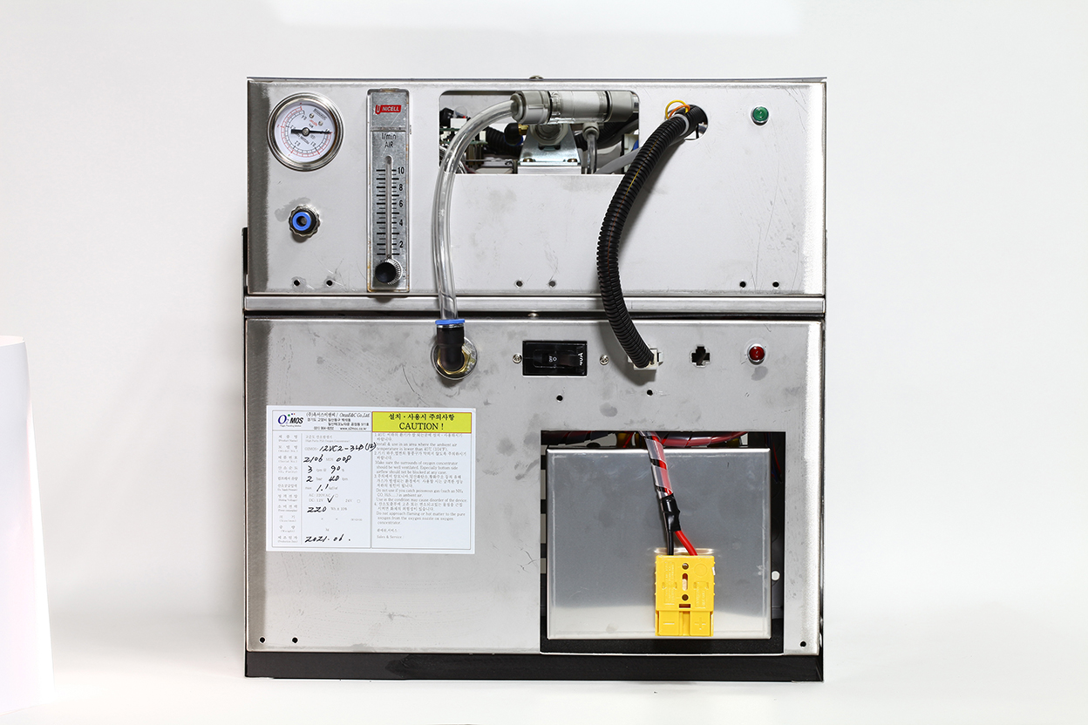

Product Specification
Category | Specification
Product Name | Vehicle-Mounted Oxygen Generator (12V)
Model Name | O2MOS-12VC2-3LB2
Manufacturer | O2MOS
Country of Origin | Republic of Korea
Oxygen Purity | 3 LPM @ 90%
Oxygen Outlet Pressure | 3 LPM @ 1 bar
Operating Voltage | 12VDC (Range: 11VDC–14VDC)  For battery or ship power / DC power supply
Current Consumption | 20A
Compressor | BLDC type
Filters Used | Intake HEPA filter, Line filter
Control Wiring | Connected via 6-pin connector (Compressor ↔ Bed Part)  - 2 wires: DC power from compressor to control PCB  - 2 wires: operation switch line  - 2 wires: DC fan power supply
Control Wiring for control | Connected via 4-pin harness (Bed Part ↔ Driver Console)
Oxygen Outlet Port | Ø6 mm
Power On/Off Switch | Built-in
Power Connection | Anderson connector (for Battery)
Oxygen Flow & Pressure Display | Built-in flowmeter and pressure gauge
Dimensions / Weight | Bed Part: 350×215×130 mm / 5 kg  Compressor Part: 350×215×222 mm / 8 kg
Material | Housing: STS304 stainless steel (protrusions included)

Installation & Wiring Instructions
1) Bed Part
- Connect the control PCB to the driver console via 4-pin harness
- Connect compressed air line (10mm urethane tube) to compressor
- Connect control and power cables via 6-pin connector to compressor
2) Compressor Part
- Attach anti-vibration pads underneath
- Fix securely with a dedicated bracket
- Connect to battery (or power supply) using power connector

Ordering Information

O2MOS-12VC2-3LB2 : Vehicle-Mounted Oxygen Generator (12V)
O2MOS-CARCONTROL-V1 : Driver-Side controller
O2MOS-RO2S-SNL : Emergency Oxygen Alarm Device(Single)

