10-Port Oxygen Flow Meter for Live Fish Transport Vehicles

Product Overview
The 10-Port Oxygen Flowmeter is a compact and efficient distribution system that supplies both pure and emergency oxygen from an oxygen generator to each tank in a live fish transport vehicle. Designed at half the size of conventional models, it optimizes installation space while maintaining high performance.
Even in the event of a leak in one tank, the system’s independent channel design minimizes any impact on other tanks, ensuring stable oxygen delivery throughout. Each port is equipped with a 3L fine-adjustable flowmeter, allowing precise control of oxygen flow for optimal live fish health and transport conditions.
Key Features:
- 10 independent oxygen supply ports
- Compact design (approximately 50% smaller than standard units)
- Leak-isolation structure for system stability
- 3L precision flow adjustment for each port
- Ideal for live fish transport and aquaculture applications
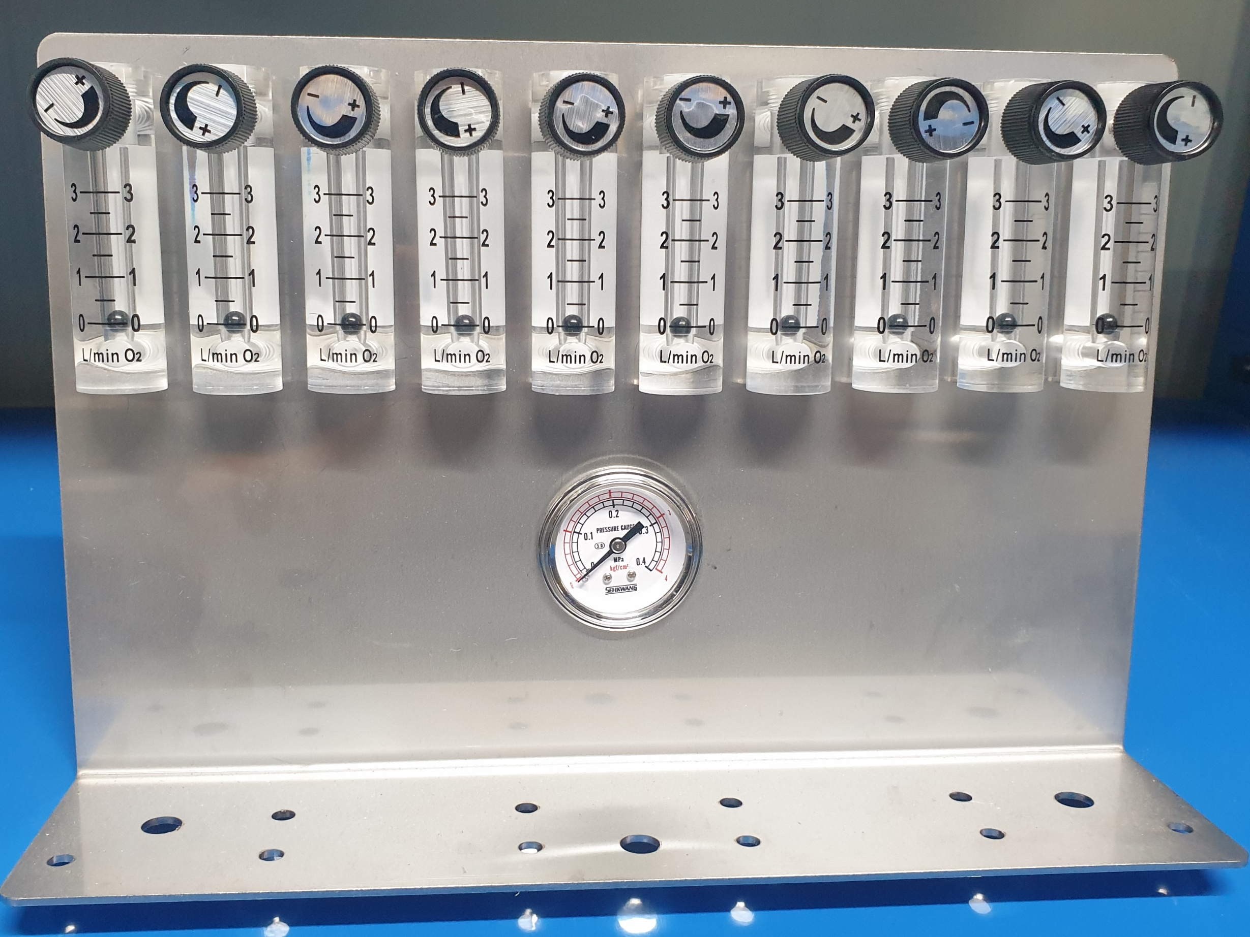

Product Specification
Category | Specification
Product Name | Flowmeter (10 Ports)
Model Name | O2MOS-3L-10LINE-FM
Component | Main body, 10 × 3L Flowmeters, 4bar Gauge, 10-Port Manifold, Fittings
Flow Rate Display | 0 ~ 3 LPM
Oxygen Inlet Line | Ø6 mm One-touch fitting (attached outside box)
Oxygen Outlet Line | Ø0.8 mm PVC nipple connection
Dimensions / Weight | 600 × 120 × 200 mm / 5 kg
Material | STS304

Installation & Wiring Instructions
L-shaped body with multiple screw holes at the bottom for secure mounting

