4-Port Oxygen Flow Meter for Live Fish Transport Vehicles

Product Overview
The 4-Port Oxygen Flow Meter efficiently distributes pure oxygen and emergency oxygen from an oxygen generator to multiple tanks in a live fish transport vehicle. Designed for performance and compactness, it is about half the size of conventional models, making installation and maintenance more convenient.
A key feature of this system is its independent flow design, which minimizes the impact on other tanks even if a leakage occurs in one tank, ensuring stable oxygen supply and fish safety. Each port is equipped with a 3L precision flow meter, allowing fine and accurate oxygen control for each tank.

Key Features:
- 4-port oxygen distribution system for live fish transport vehicles
- Supplies both pure and emergency oxygen from the generator
- Compact design — approximately 50% smaller than conventional models
- Independent flow structure minimizes inter-tank impact in case of leakage
- Equipped with 3L precision flow meters for fine adjustment

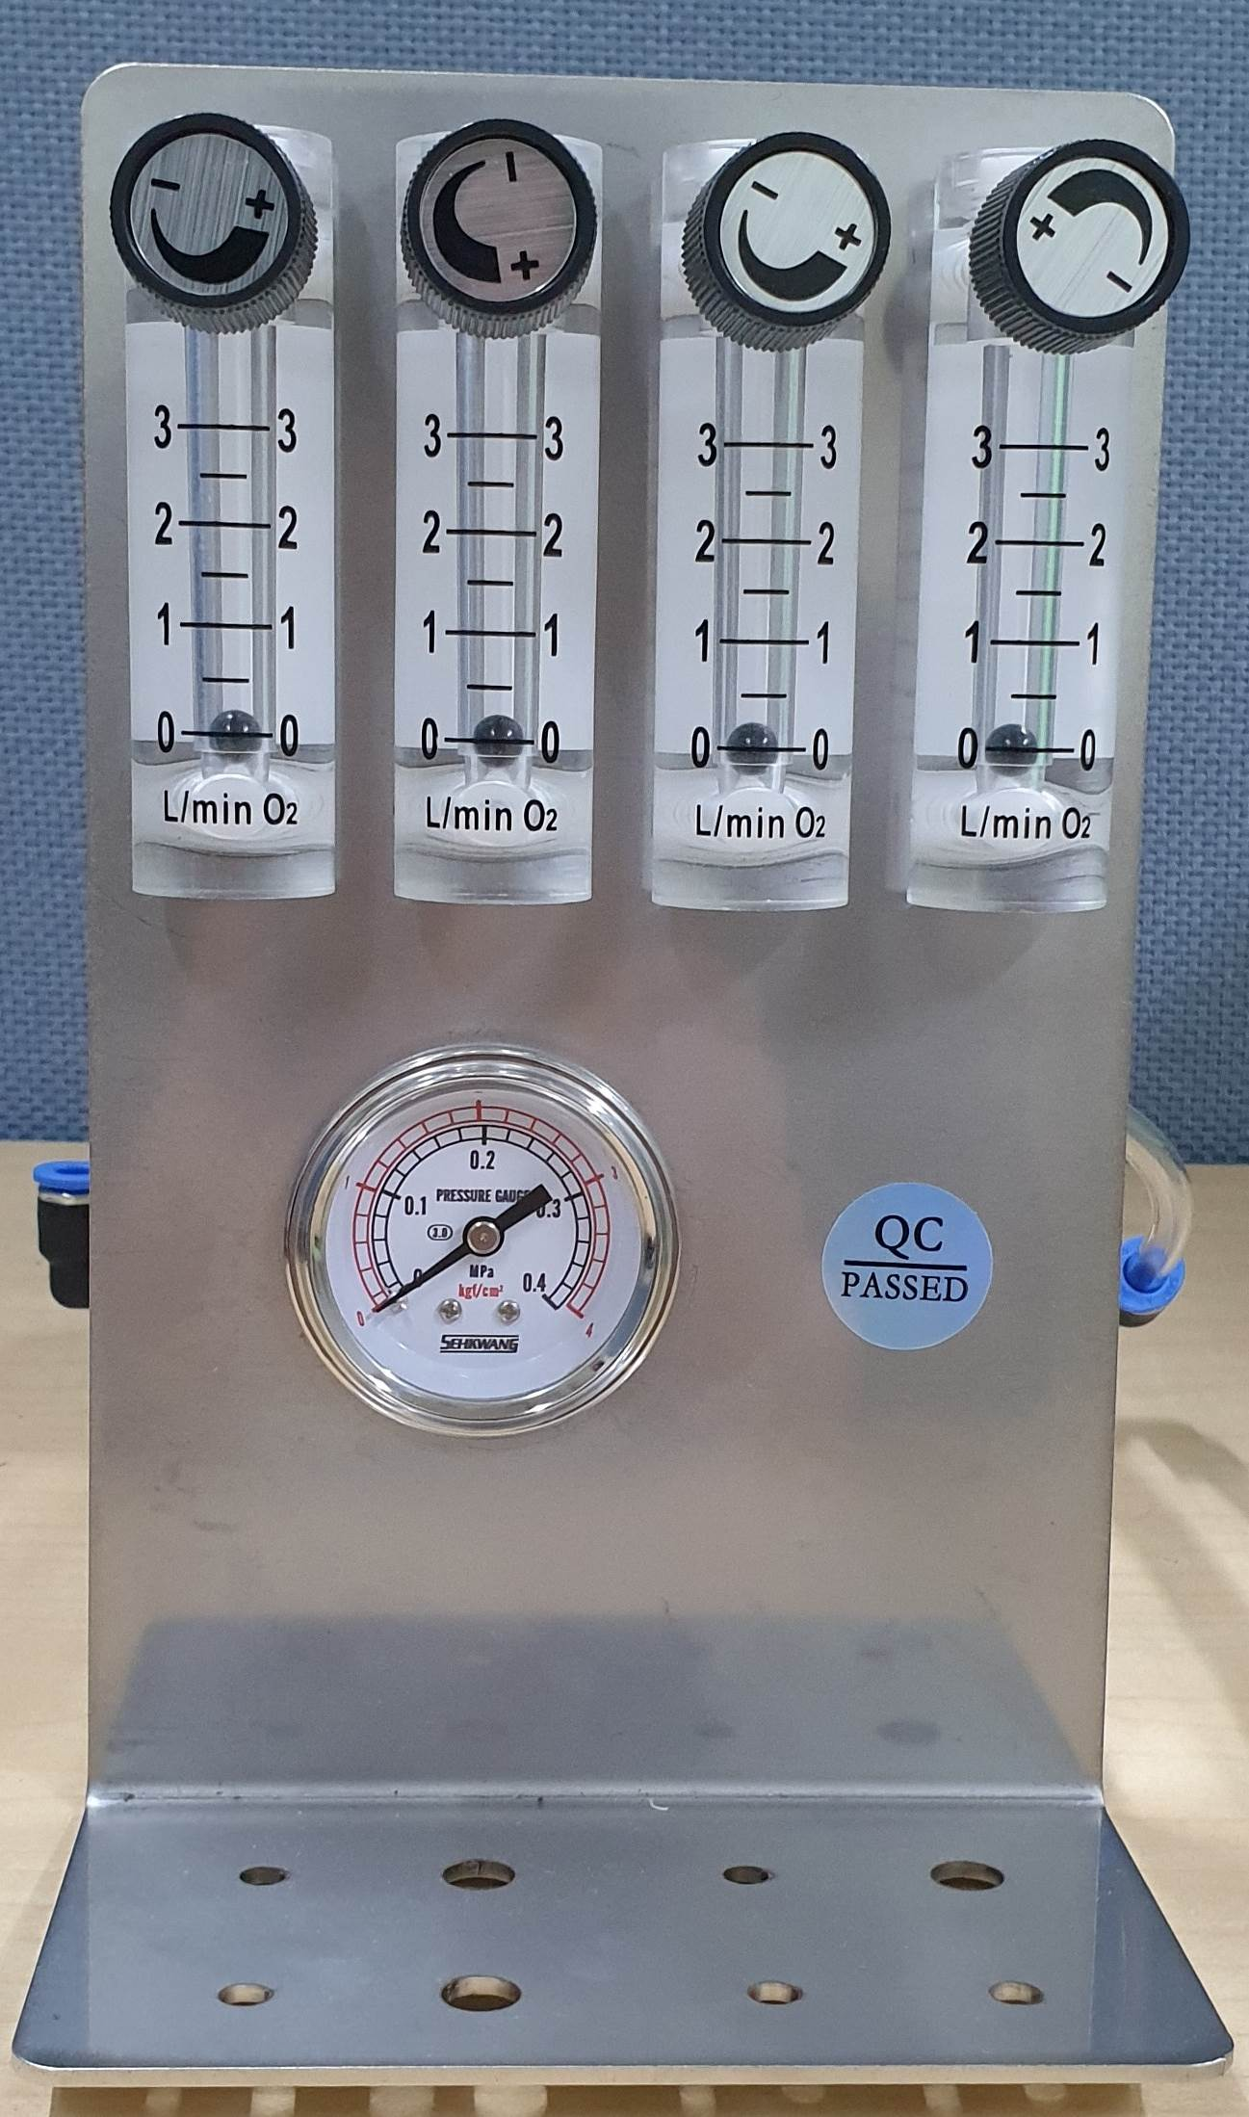

Product Specifications
Category | Specification
Product Name | Flow Meter (4-Port)
Model Name | O2MOS-3L-4LINE-FM
Device Components | Main body, four 3L flow meters, 4 bar pressure gauge, 4-port manifold, fittings
Flow Rate Display | 0 ~ 3 LPM
Oxygen Inlet Line | 6mm one-touch fitting connection (attached to outer box casing)
Oxygen Supply Line | 8mm PVC nipple
Dimensions (mm) / Weight | 120 × 150 × 120 / 1.2Kg
Material | STS304

