Driver-Side Oxygen Generator Controller

Product Overview
The Vehicle Oxygen Generator Controller enables the driver to operate and monitor the PSA oxygen generator directly from the driver’s seat.
This control unit allows remote ON/OFF operation, real-time monitoring of the machine’s operating status, and oxygen supply condition through an intuitive interface.
By integrating the generator’s control and status monitoring into the vehicle dashboard, the system enhances user convenience, safety, and operational efficiency during transport and field operations.
Key Features:
- Remote ON/OFF control of the PSA oxygen generator from the driver’s seat
- Real-time display of machine operating status and oxygen supply level
- Compact and durable design suitable for vehicle installation
- Improves operational safety and ease of use during oxygen supply in mobile environments
- Alarm activates upon abnormal condition detection

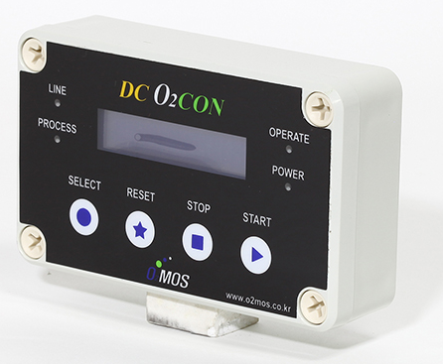

Product Specification
Category | Specification
Product Name | Driver-Side Controller
Model Name | O2MOS-CARCONTL-V1
Control Method & Functions | • Power supplied from oxygen generator part  • ON/OFF control of oxygen generator  • Monitoring operation status and oxygen delivery status  • Recording and storing usage time and method
Connection | 4-pin for Power and Control
Display | Voltage, Oxygen Line Pressure, Normal operation Status
Communication | RS-485
Dimensions | 130 × 35 × 80 mm
Weight | 200g
Housing Material | Plastic

Installation & Wiring Instructions
• Installed on the driver’s side using bracket screws or double-sided tape
• Control cable routed from driver’s side to oxygen generator
• Protective tubing used for control cables

Ordering Information
O2MOS-12VC2-3LB2 : 3LPM, Vehicle-Mounted Oxygen Generator (12V)
O2MOS-24VC2-3LB2 : 3LPM, Vehicle-Mounted Oxygen Generator (24V)
O2MOS-12VC1-7LB2 :7LPM, Vehicle-Mounted Oxygen Generator (12V)
O2MOS-24VC1-7LB1 : Vehicle-Mounted Oxygen Generator (24V)
O2MOS-CARCONTROL-V1 : Driver-Side controller
O2MOS-RO2S-SNL : Emergency Oxygen Alarm Device(Single)

