Oxygen Alarm System – O2CALL Premium

Product Overview
The O2Call Premium is an advanced oxygen monitoring and safety device designed to ensure stable and safe oxygen supply from a high-purity PSA oxygen generator or ambient oxygen source.
It is equipped with a high-precision oxygen sensor and pressure sensor to continuously monitor oxygen purity and supply pressure.
In addition, O2Call Premium detects abnormalities in the power supply of connected equipment (such as the oxygen generator) and provides visual and audible alarms in case of any malfunction.
The system instantly detects critical issues such as decreased oxygen concentration, pressure fluctuation, or oxygen leakage, and triggers alarms to prevent accidents or oxygen supply failure.
For reliable alerting, the device includes a warning light, speaker, and two non-contact voltage alarm outputs for integration with external safety systems.

Key Features:
- Built-in high-precision oxygen and pressure sensors
- Real-time monitoring of oxygen purity, supply pressure, and power status
- Automatic alarm for oxygen concentration drop, pressure anomaly, or power failure
- Equipped with warning light, speaker, and dual non-contact voltage outputs
- Enhances operational safety in oxygen supply environments

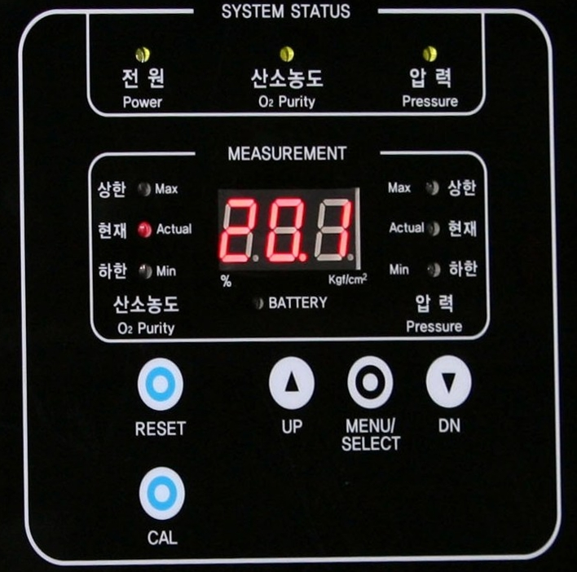
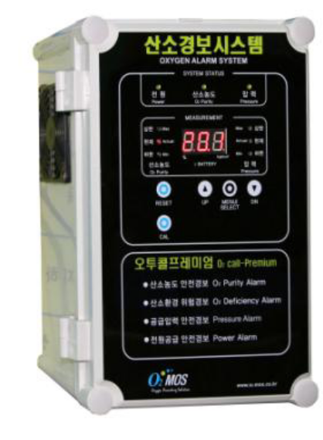

Specifications
Category | Specification
Product Name | Oxygen Alarm System
Model | O2CALL Premium
Manufacture | O2MOS
Country of Origin | Republic of Korea
Functions | Detects and alarms for Oxygen purity drop  Pressure drop  Power outage
Oxygen Sensor Model | Zirconia solid electrode
Oxygen Detection Range (Display) | 0.0% – 99.9%
Oxygen Detection Resolution | 0.1%
Effective Detection Range | 75.0% – 95.0%
Alarm Setting (Purity) | User-defined between 0.1% – 99.9%  Upper/lower limit alarm output
Calibration (Purity) | Adjustable in 0.1% units
Purity Measurement Cycle | Every 10 minutes for 10 seconds(Valve open method)
Detection Range (Pressure) | 0.0 – 3.0 kgf/cm²
Resolution (Pressure) | 0.1 kgf/cm²
Accuracy (Pressure) | ±0.1 (≤2.0 kgf/cm²), ±0.3 (≤3.0 kgf/cm²)
Alarm Setting (Pressure) | User-defined between 0.1 – 3.0 kgf/cm²
Power Outage Detection | Detected within 2 seconds
Alarm Output | Red LED blink and built-in speaker alarm  Also includes 2 dry contact signals (AC220V 10A MAX / DC100V 5A MAX)
Communication | RS-485
Oxygen Inlet Port | Ø6 mm
Power Supply | 220VAC, 50/60Hz  Includes 9V rechargeable backup battery
Power Consumption | ≤ 10W
Operating Conditions | 0°C – 60°C, 0% – 85% RH
Dimensions / Weight | 210 × 160 × 300 mm / 3.0 kg
Material | ABS enclosure

