Emergency Oxygen Supply Control Device (Single Type)

Product Overview
The Vehicle Emergency Oxygen Supply Control Unit is designed to ensure the stable and continuous delivery of oxygen generated by the PSA oxygen generator in mobile environments. It connects directly to the oxygen outlet of the PSA generator and continuously monitors the oxygen pressure level to detect any abnormalities in the oxygen supply.
In the event of an oxygen supply failure or a power issue with the air compressor or PSA generator, the system automatically activates the emergency oxygen supply line, opening the valve of a backup high-pressure oxygen cylinder to maintain uninterrupted oxygen delivery.
Additionally, the unit provides visual and audible alarms to alert the operator of abnormal pressure or power conditions, ensuring safe and reliable operation.
Key Features:
- Continuous monitoring of oxygen pressure and generator power status
- Automatic switchover to emergency oxygen supply during system failure
- Integrated alarm system for oxygen supply and power faults
- Ensures stable and safe oxygen delivery in vehicle-mounted PSA systems

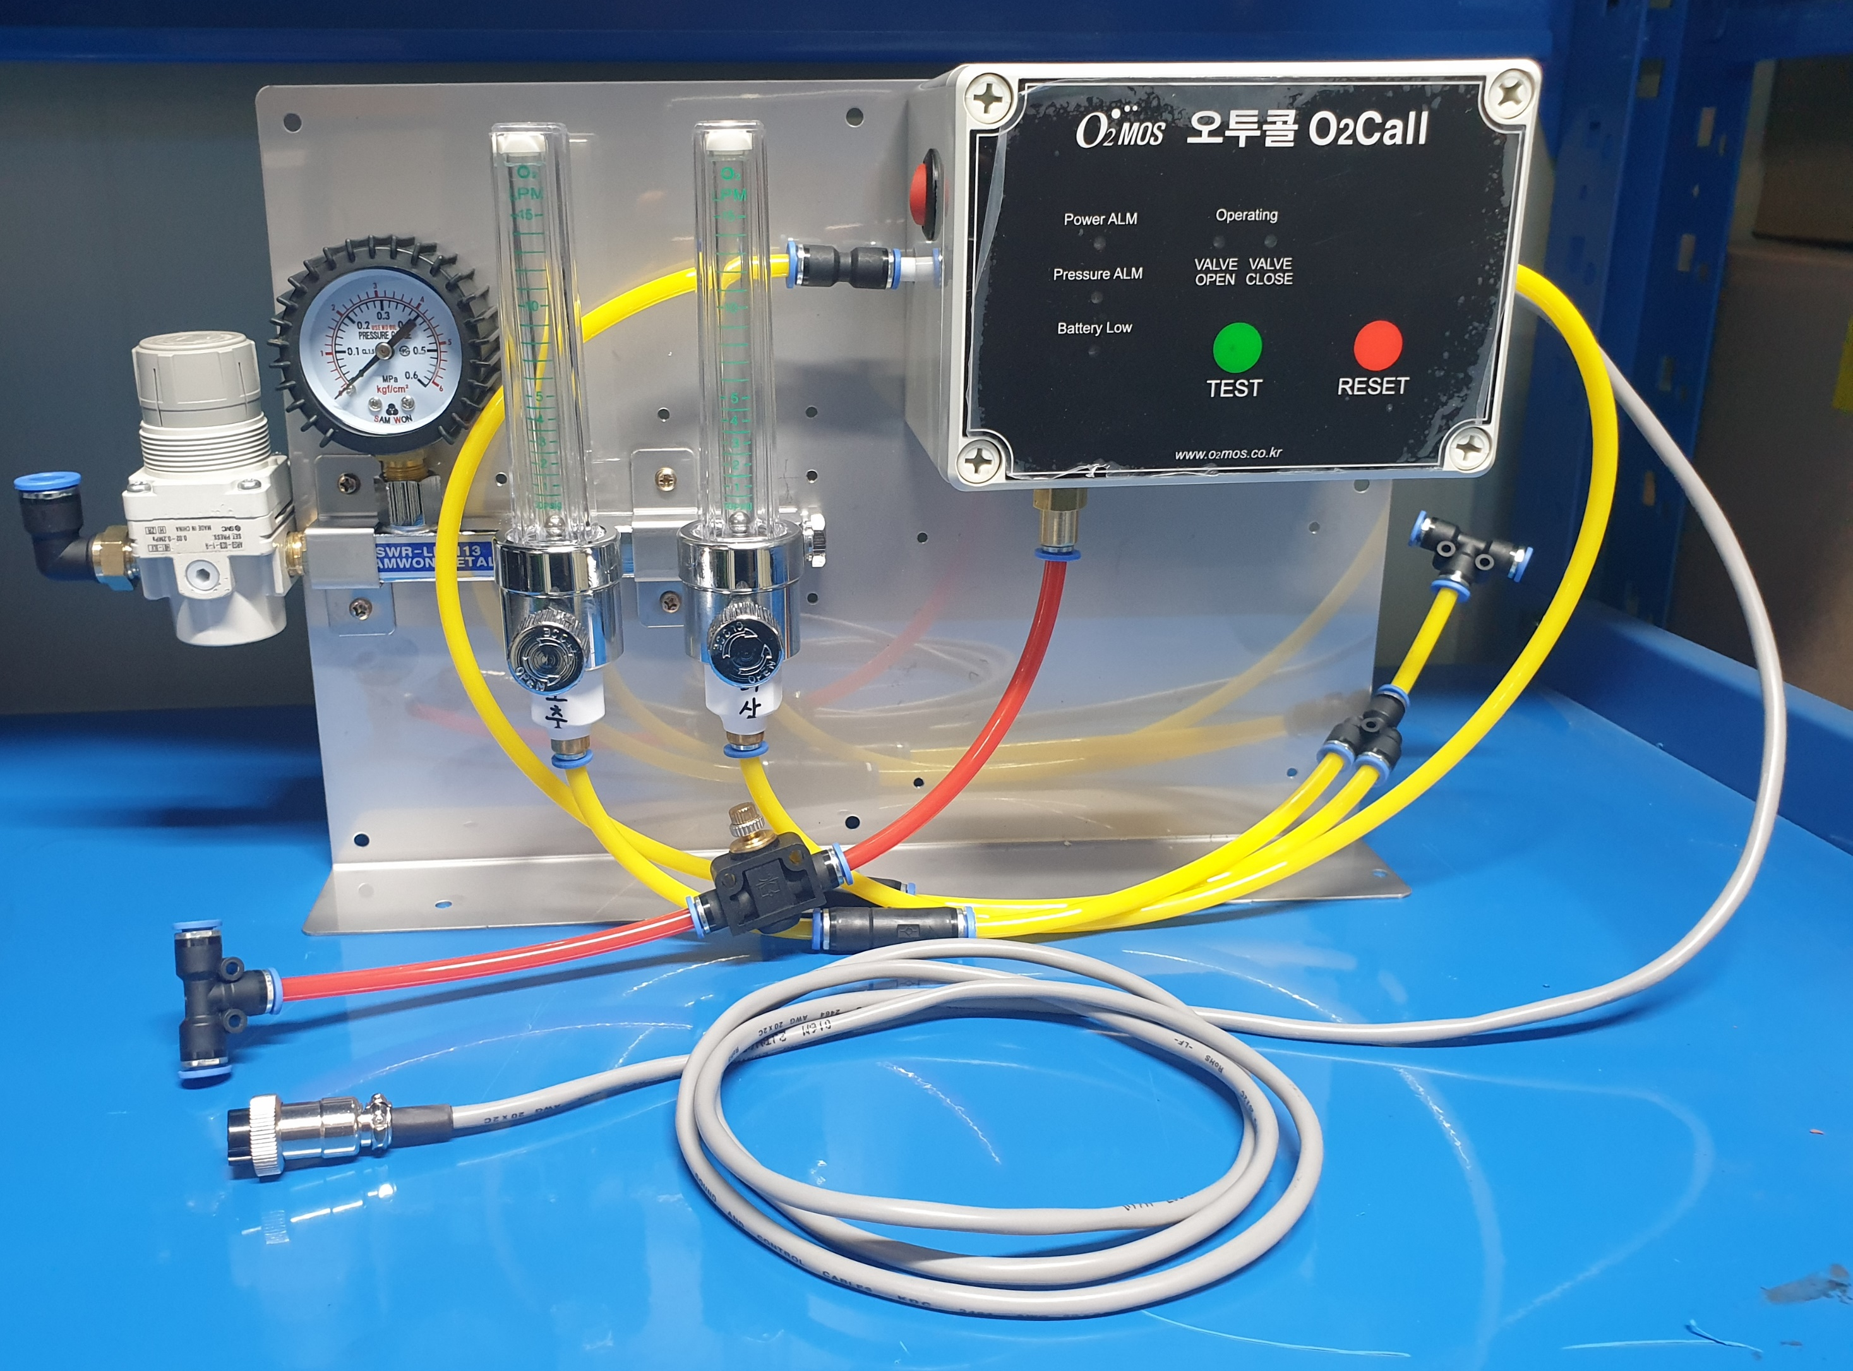

Product Specifications
Category | Specification
Product Name | Emergency Oxygen Alarm Device (Single)
Model Name | O2MOS-RO2S-SNL
Manufacture | O2MOS
Country of Origin | Republic of Korea
Detection Function | PSA Oxygen pressure detection (6 mm one-touch fitting)  Power abnormality detection (DC power)
Internal Configuration | 2-port flowmeter (Manual Operation: 1-port, Emergency Operation: 1-port)  DC power & pressure alarm  Emergency valve  Includes DC battery for backup power
Emergency Oxygen Inlet | 10 mm one-touch fitting
Emergency Oxygen Outlet | 6 mm one-touch fitting  Auto supply upon alarm valve activation
Dimensions / Weight | 340 × 50 × 240 mm / 3 kg
Material | STS304

Installation & Wiring Instructions

- Wall-mounted or installed with vibration-damping pad on base plate using direct screws
- Connect pressure sensor and emergency/supplementary oxygen to discharge hose line.
- Connect power sensor wires to compressor power connector.
- Connect emergency oxygen to 2-port flowmeter

